**Hawk Installation & Configuration**

**Installation steps:**

Step 1: Make sure RV & EMS are installed in the server otherwise install those two components first.

Step 2: Copy the Linux version of hawk software (TIB_hawk_5.2.0_linux26gl23_x86_64) to a location in server.

Step 3: Open the putty and navigate to the directory where the software has been kept.

Step 4: Run the below command:

./ TIBCOUniversalInstaller-lnx-x86-64.bin –console

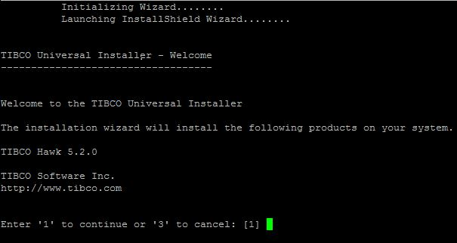

Step 5: Provide the new TIBCO HOME if required. Better to keep new home for HAWK.

* Accept the license agreement.

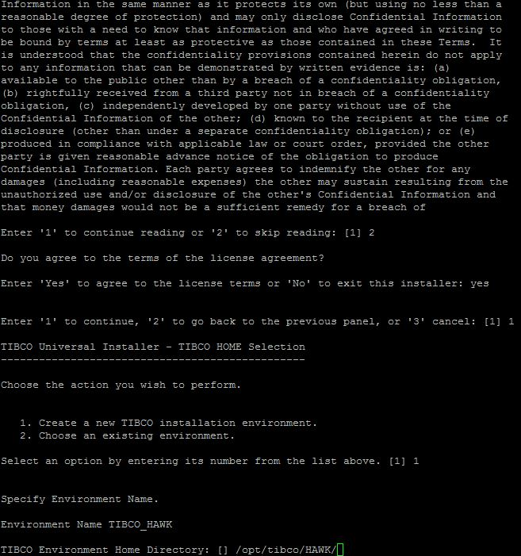

* Install both **TIBCO Hawk 5.2 Components & TIBCO Hawk Admin Agent** at a time or we can install each of them individually.

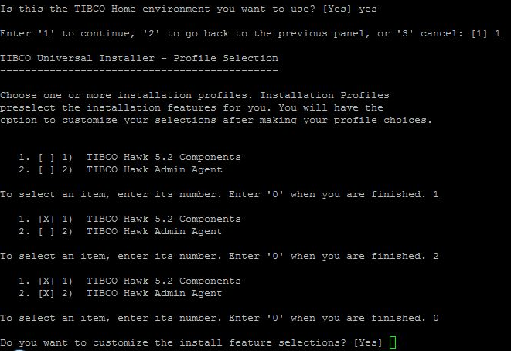

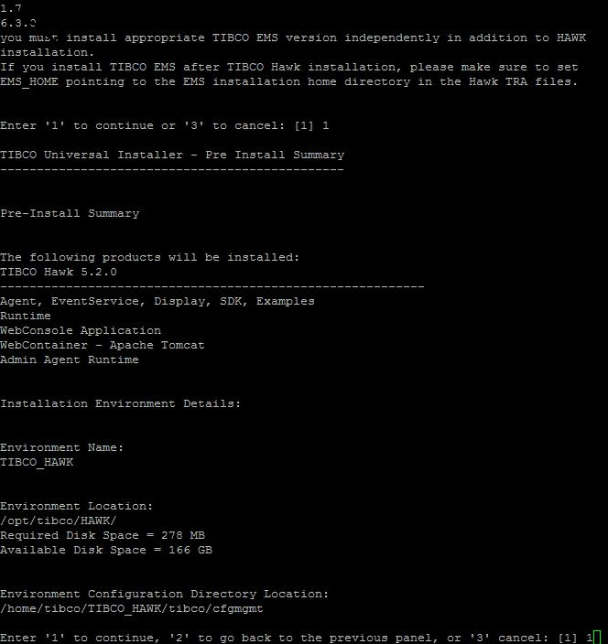

* Use previously installed JVM in the machine.
* Finish installation

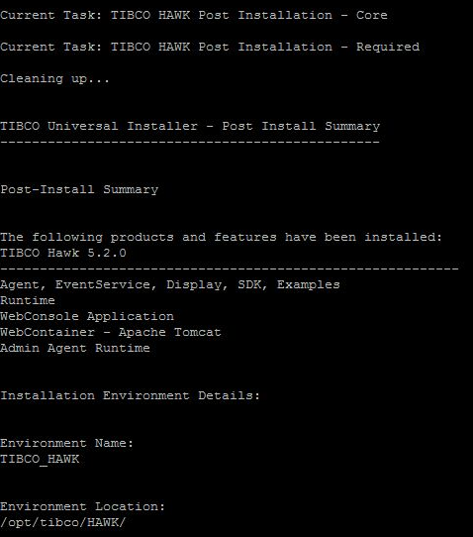

**Post Installation:**

**Start Hawk Components:**

* Start Hawk Microagent by executing starthma. The starthma must be run as root.

<HAWK_HOME>/hawk/5.2/bin> nohup ./starthma 2>&1 &

* Start RV if not running.

<HAWK_HOME>tibrv/8.4/bin> nohup ./rvd 2>&1 &

* Start tibhawkagent.

<HAWK_HOME>/hawk/5.2/bin> nohup ./tibhawkagent 2>&1 &

**Configuration steps:**

Since we have used different TIBCO HOME for hawk installation. So, we need to point RV or EMS location in all the .tra files present under *CONFIG_HOME/bin* directory. Provide the correct values for **tibco.env.EMS_HOME & tibco.env.RV_HOME** environment variables in all the TRA configuration files.

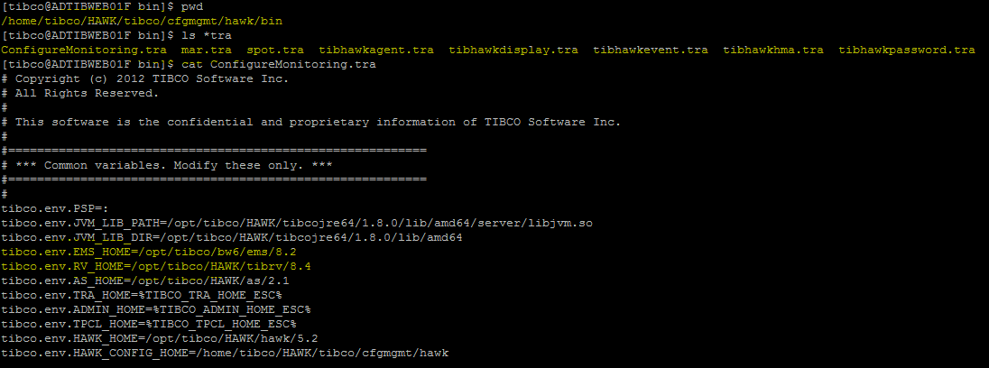

**Configuring Hawk Console at runtime:**

* To configure Hawk WebConsole runtime environment, copy the Java libraries from respective locations (EMS_HOME/lib & RV_HOME/lib) to the below location:

HAWK_HOME/webconsole/tomcat/lib directory.

* Copy the following Java libraries for TIBCO Rendezvous as transport:

— RV_HOME/lib/tibrvj.jar

* Copy the following Java libraries for TIBCO EMS as transport:

— EMS_HOME/lib/tibrvjms.jar

— EMS_HOME/lib/tibjms.jar

— EMS_HOME/lib/tibcrypt.jar

— EMS_HOME/lib/jms.jar (whenever EMS version is below 8.0) or

— EMS_HOME/lib/jms-2.0.jar (in case of EMS 8.x)

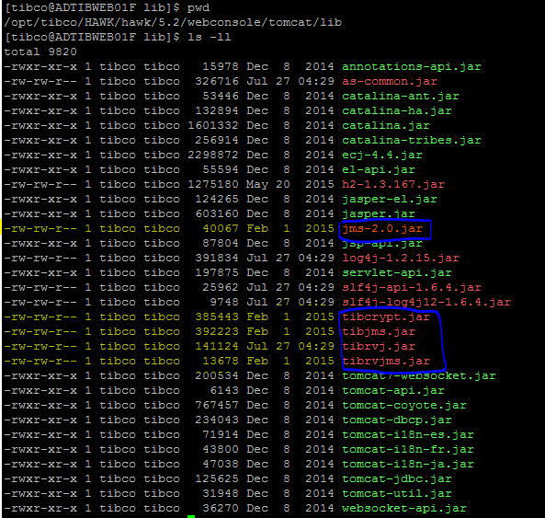

* Also navigate to the files HAWK_HOME/webconsole/startwebconsole.sh and HAWK_HOME/webconsole/tomcat/bin/setenv.sh to set RV_HOME and EMS_HOME correctly.
* Start Hawk Webconsole by navigating HAWK_HOME\webconsole folder.

Run the following executables:

— tibhawkh2db to start the database.

nohup ./tibhawkh2db 2>&1 &

— startwebconsole.sh to start the Webconsole.

nohup ./startwebconsole.sh 2>&1 &

* Start the Hawk WebConsole in your browser’s address

_address>/<port_number>/hawkwebconsole

Where the default <port_number> is 8080. But in DEV environment it is configured currently for port 8200.

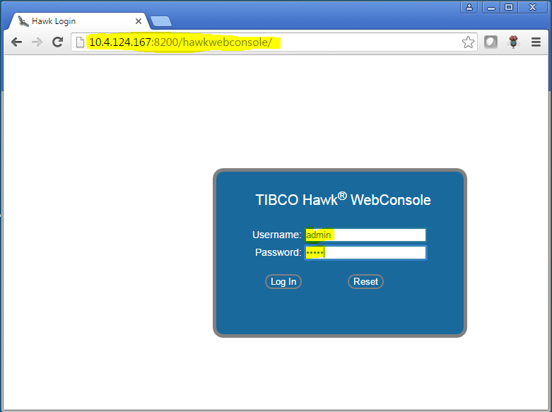

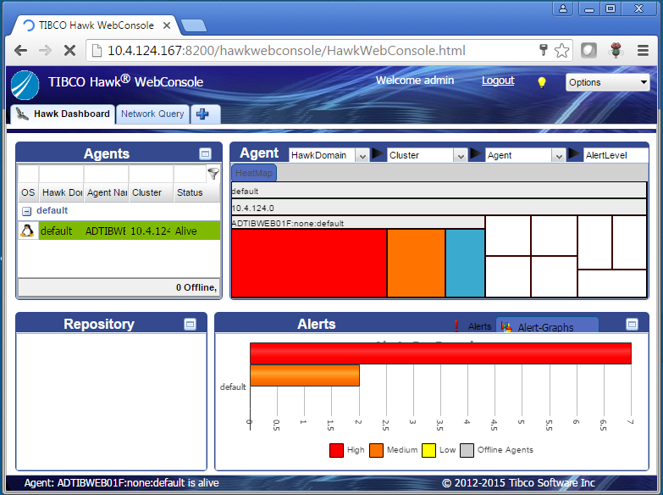

Note: By default port for webconsole is 8080. We can modify it by editing server.xml present at below location:

<HAWK_HOME>/hawk/5.2/webconsole/tomcat/conf

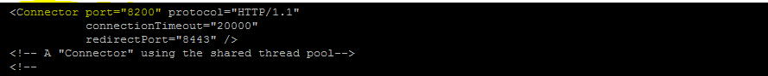

**Configuring Tea admin for hawk:**

* To configure tea admin, navigate to BW6_HOME/tea/<version>/bin and open tea.tra files for editing.
* Set the hawk home property:

tibco.env.HAWK_HOME= Hawk_Home/<version>

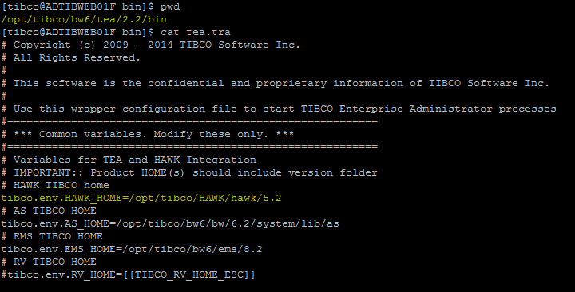

* Navigate to a directory HAWK_HOME\tea\agents\hawk\<version>\bin
* Run tibhawkteaagent:

nohup ./tibhawkteaagent 2>&1 &

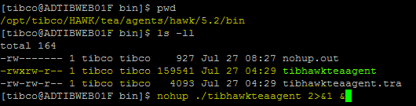

* Verify the configuration by login to tea admin UI.

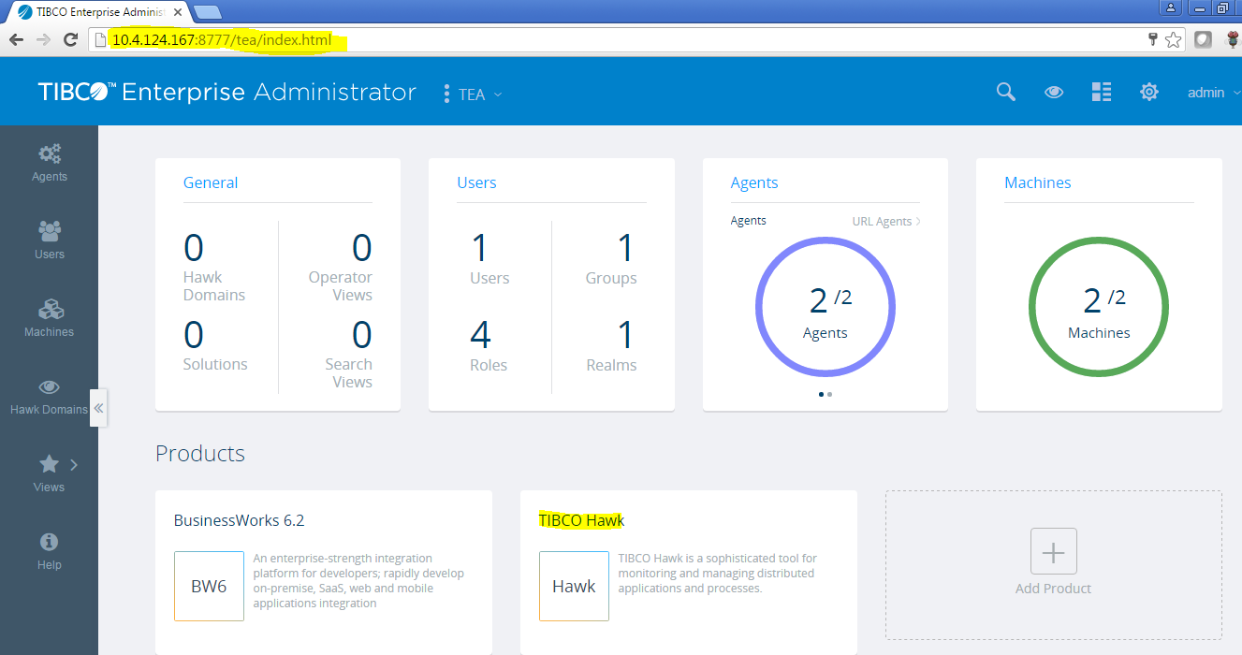

* Click on highlighted HAWK.

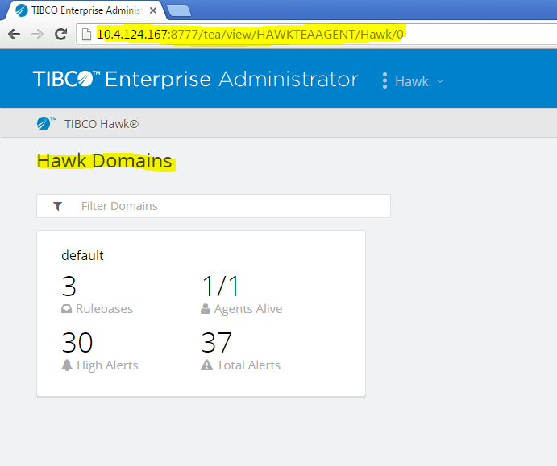

**Configuring EMS microagents for hawk:**

To configure EMS microagents follow the below steps:

* Make sure that TIBCO Enterprise Message Service is installed and running.



* Copy the file hawkemsadmin.hma from TIBCO_HOME/hawk/<version>/plugin/ems to CONFIG_FOLDER/hawk/plugin.
* 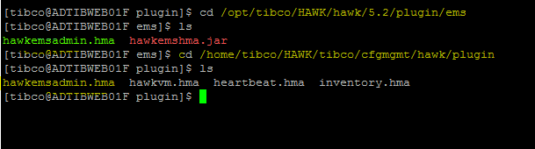 Edit hawkagent.cfg in CONFIG_FOLDER/hawk/bin and set the following option:

hma_plugin_dir CONFIG_FOLDER/hawk/plugin

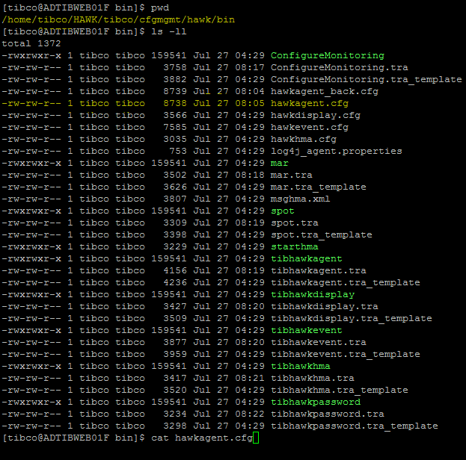

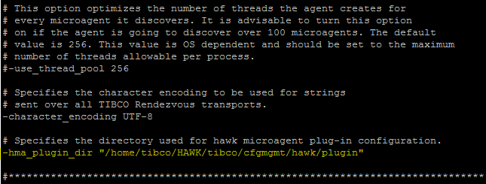

* Navigate to CONFIG_FOLDER/hawk/plugin directory and open the hawkemsadmin.hma file in a text editor and modify the RV_HOME & EMS_HOME.

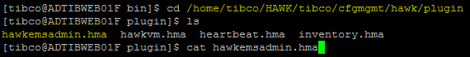

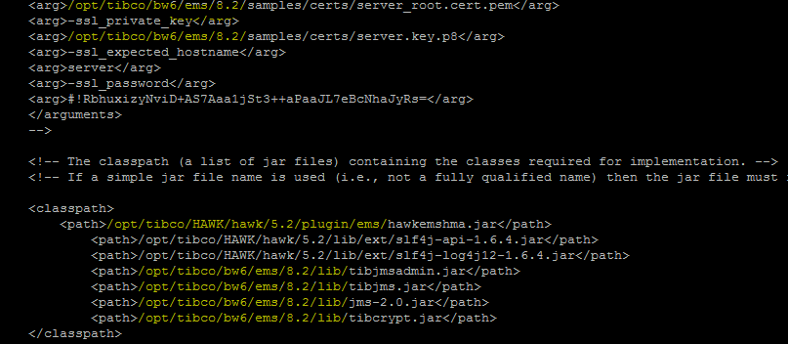

* Restart tibhawkagent

/opt/tibco/HAWK/hawk/5.2/bin> nohup ./tibhawkagent 2>&1 &

* Verify EMS configuration by login to webconsole/tea UI and click on microagents tab.

